Skewness, FFT size = 512

Axial integral, 256 dim feature vector

Average Accuracy: 0.8227285572982902

Average Precision: 0.8395767072550046

Average Recall: 0.793823163607583

Radial integral, 256 dim feature vector

Average Accuracy: 0.7721580471951393

Average Precision: 0.7707553941744729

Average Recall: 0.7679864500207403

Radial integral, 128 dim feature vector

Average Accuracy: 0.7721580471951393

Average Precision: 0.7707553941744729

Average Recall: 0.7679864500207403

Radial integral, 64 dim feature vector

Average Accuracy: 0.7721580471951393

Average Precision: 0.7707553941744729

Average Recall: 0.7679864500207403

Bicoherence, FFT size = 512

Axial integral – 256 dim feature vector

Average Accuracy: 0.9381446940794123

Average Precision: 0.9282986880344598

Average Recall: 0.9464149477950927

Radial integral – 256 dim feature vector

Average Accuracy: 0.9060159672177477

Average Precision: 0.891256759848168

Average Recall: 0.9215739797688375

Radial integral – 128 dim feature vector

Average Accuracy: 0.9060159672177477

Average Precision: 0.8911946866017372

Average Recall: 0.9215155002366737

Radial integral – 64 dim feature vector

Average Accuracy: 0.9048237247421224

Average Precision: 0.8901652721659502

Average Recall: 0.9205251210629329

Bicoherence – FFT size = 1024

Axial integral

Average Accuracy: 0.932187014271584

Average Precision: 0.9272845831328667

Average Recall: 0.9359348923234931

Radial integral

Average Accuracy: 0.9066094390278365

Average Precision: 0.889552383441395

Average Recall: 0.9251221980795602

Skewness – FFT size = 1024

Axial integral

Average Accuracy: 0.8233273279638265

Average Precision: 0.8375129409254891

Average Recall: 0.8003159182174846

Radial integral

Average Accuracy: 0.7715734068107956

Average Precision: 0.7664942942532845

Average Recall: 0.7747454788462766

Bicoherence – FFT size = 128

Axial integral

Average Accuracy: 0.928604987989261

Average Precision: 0.9257694932358772

Average Recall: 0.931028811629669

Radial integral

Average Accuracy: 0.8964815599830438

Average Precision: 0.8876869983914716

Average Recall: 0.9054804808138712

Skewness – FFT size = 128

Axial integral

Average Accuracy: 0.8179507559700439

Average Precision: 0.8312454336383943

Average Recall: 0.7918746840638302

Radial integral

Average Accuracy: 0.8084481418680232

Average Precision: 0.8101386261242067

Average Recall: 0.8004935299166132

Bicoherence – FFT size = 64

Axial integral

Average Accuracy: 0.8845873957891761

Average Precision: 0.9015075684375773

Average Recall: 0.8606066995421227

Radial integral

Average Accuracy: 0.8625741839762611

Average Precision: 0.8729857889708311

Average Recall: 0.8448179130176369

Skewness – FFT size = 64

Axial integral

Average Accuracy: 0.7870178041543026

Average Precision: 0.8378330129693271

Average Recall: 0.7052202411617093

Radial integral

Average Accuracy: 0.7590539776741558

Average Precision: 0.7903249904004431

Average Recall: 0.7001530815544552

Using same prompts for synthetic/natural (LJ-prompts)

Bicoherence – FFT size = 256

Axial integral

Average Accuracy: 0.9393140128079889

Average Precision: 0.9348506674955163

Average Recall: 0.9410874067503954

Radial integral

Average Accuracy: 0.8978508629111038

Average Precision: 0.8757880669616075

Average Recall: 0.9216237316124672

Skewness – FFT size = 256

Ax

Average Accuracy: 0.8155125004522595

Average Precision: 0.8284787216499655

Average Recall: 0.78305692178949

Rad

Average Accuracy: 0.7824649951155976

Average Precision: 0.7782262060624723

Average Recall: 0.7744824919003057

256

B ax

Average Accuracy: 0.9405203476049173

Average Precision: 0.9360976174981094

Average Recall: 0.943561946290302

Average ROC AUC: 0.9833127683124083

B rad

Average Accuracy: 0.897085629504027

Average Precision: 0.8770882005206152

Average Recall: 0.9209895340348222

Sk ax

Average Accuracy: 0.8126059771089444

Average Precision: 0.8292829320280302

Average Recall: 0.7831541434775143

Sk rad

Average Accuracy: 0.783465804719514

Average Precision: 0.7825528332956565

Average Recall: 0.7789058255097906

32

B ax

Average Accuracy: 0.8381729546417974

Average Precision: 0.8563845814574202

Average Recall: 0.8089123362148752

B rad

Average Accuracy: 0.8393634308322735

Average Precision: 0.8608220997221899

Average Recall: 0.8048774172816284

Sk ax

Average Accuracy: 0.7780945315811785

Average Precision: 0.8233169326303654

Average Recall: 0.7017014007955398

Sk rad

Average Accuracy: 0.7614278649145118

Average Precision: 0.7982118951238013

Average Recall: 0.693760539787746

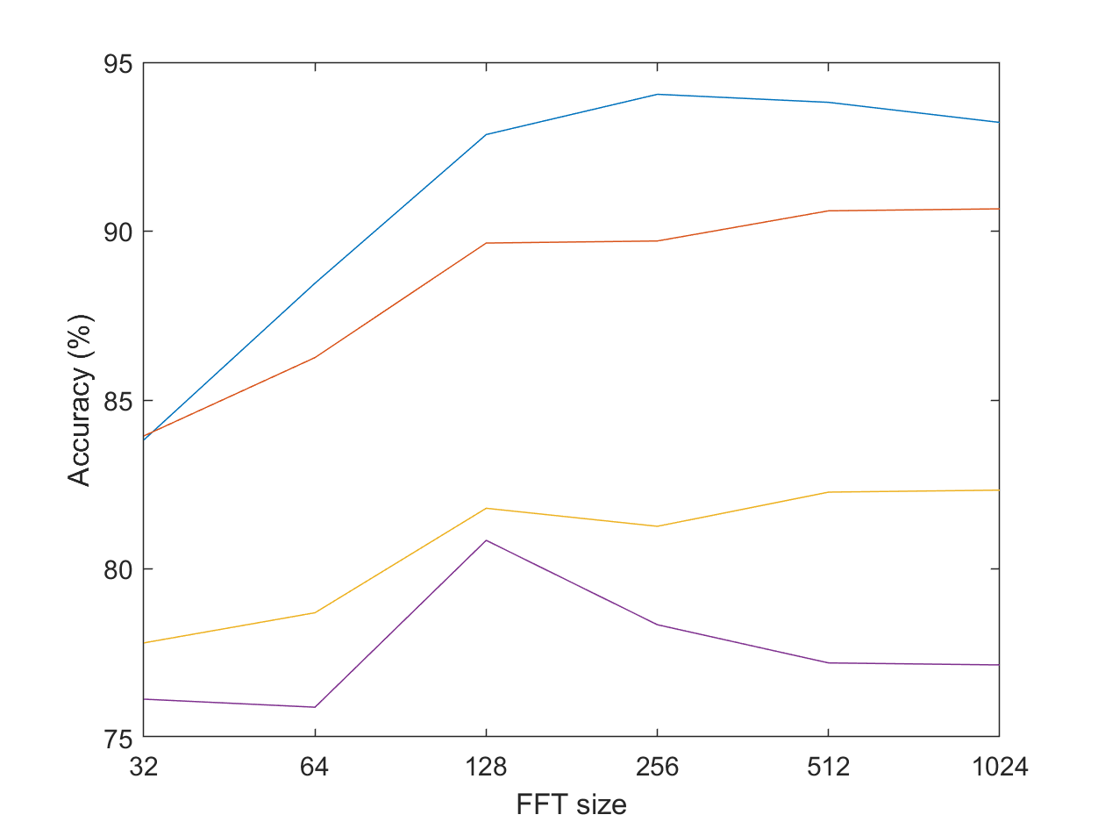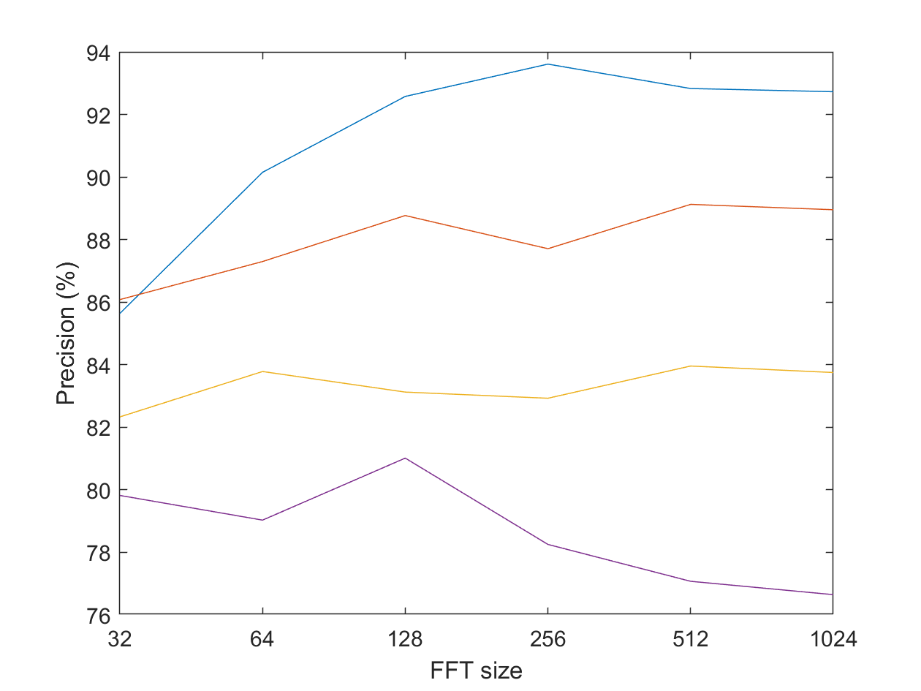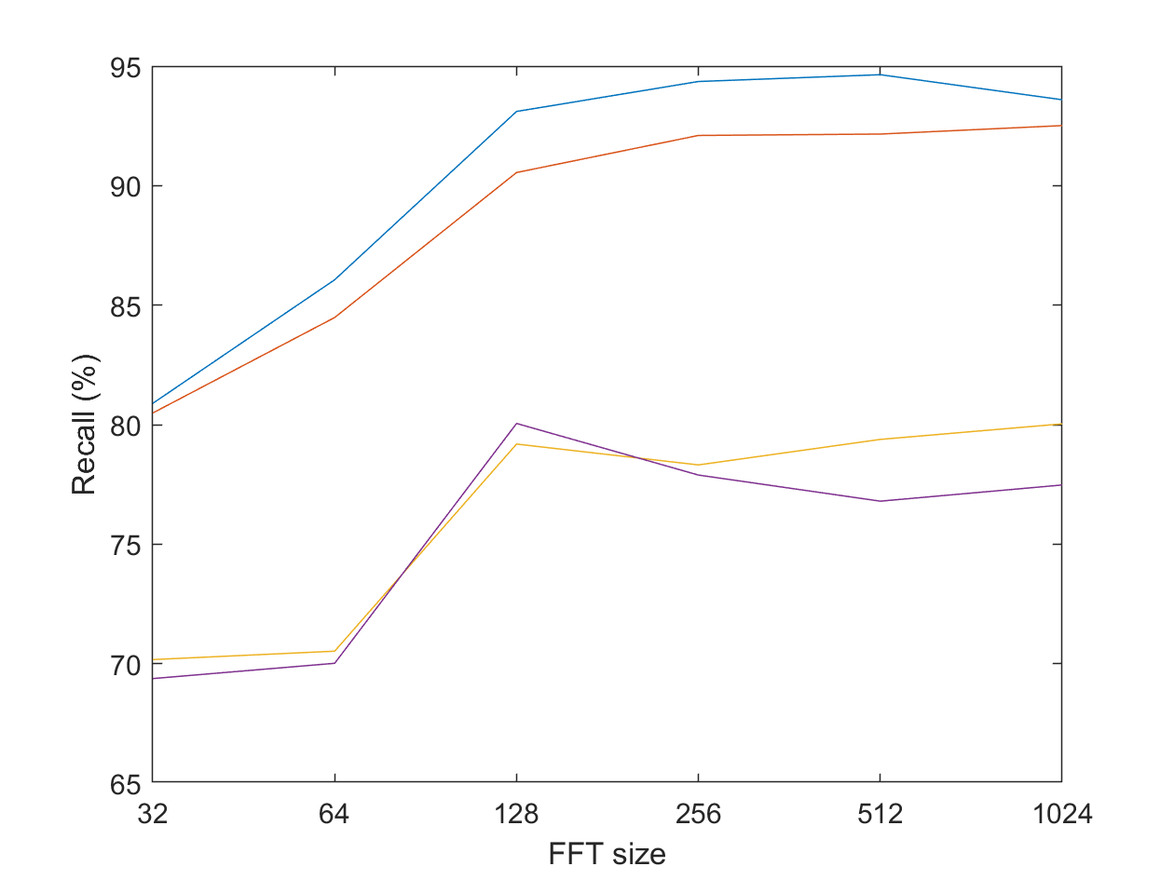

Legend:

Blue = Bicoherence, Axial integral

Red = Bicoherence, Radial integral

Yellow = Skewness, Axial integral

Purple = Skewness, Radial integral

$$Accuracy=\frac{True Positives+True Negatives}{Total number of instances}$$

$$Precision=\frac{True Positives}{True Positives+False Positives}$$

$$Recall= \frac{True Positives}{True Positives+False Negatives}$$

From Chat GPT:

**1. Accuracy**

* **Definition**: Accuracy is the ratio of correctly predicted instances (both true positives and true negatives) to the total number of instances.
$Accuracy=\frac{True Positives+True Negatives}{Total number of instances}$

* **Use Case**: Accuracy is a good measure when the classes are balanced, meaning there are roughly the same number of instances for each class. However, it can be misleading in cases of class imbalance (e.g., when one class is much more frequent than the other).

**2. Precision**

* **Definition**: Precision is the ratio of correctly predicted positive instances to the total predicted positive instances. It measures how many of the positive predictions made by the model are actually correct.
$Precision=\frac{True Positives}{True Positives+False Positives}$

* **Use Case**: Precision is important when the cost of false positives is high. For example, in spam detection, you want to minimize the number of legitimate emails incorrectly classified as spam.

**3. Recall (Sensitivity or True Positive Rate)**

* **Definition**: Recall is the ratio of correctly predicted positive instances to all actual positive instances in the data. It measures how well the model captures all the true positives.
$Recall= \frac{True Positives}{True Positives+False Negatives}$

* **Use Case**: Recall is critical when the cost of false negatives is high. For example, in disease diagnosis, you want to identify as many actual positive cases as possible, even if it means increasing the number of false positives.

$$F1 score=2×\frac{Precision×Recall}{Precision+Recall}$$